

EFFICIENTNET_V2_S BASED TRANSFER LEARNING FRAMEWORK FOR INDIAN CATTLE BREED RECOGNITION
A PROJECT REPORT
Submitted by
ADITYA V S – 20221ISE0032 CHIRANTHAN T C NADIG- 20221ISE0062
Under the guidance of,

Mr. JOHN BENNET JOHNSON
in partial fulfilment for the award of the degree of
BACHELOR OF TECHNOLOGY
IN
INFORMATION SCIENCE AND ENGINEERING


PRESIDENCY UNIVERSITY BENGALURU APRIL 2026


PRESIDENCY SCHOOL OF COMPUTER SCIENCE AND ENGINEERING
BONAFIDE CERTIFICATE
Certified that this report “EfficientNet_V2_S Based Transfer Learning Framework For Indian Catte Breed Recognition” is a Bonafide work of “ADITYA V S (20221ISE0032), CHIANTHAN T C NADIG (20221ISE0062)”, who have successfully carried out the project work and submitted the report for partial fulfilment of the requirements for the award of the degree of BACHELOR OF TECHNOLOGY in INFORMATION SCIENCE AND ENGINEERING, during 2025-26.

Mr. John Bennet J Project Guide PSCS
Presidency University
Ms. Sumita Guddin
Program Project Coordinator
PSCS
Presidency University

Dr. Gopal Krishna Shyam Head of the Department, PSCS-COM,ISE.
Presidency University
Dr. Duraipandian N
Dean PSCS
Presidency University

Examiners

Sl. no. | Name | Signature | Date
1
2

PRESIDENCY UNIVERSITY

PRESIDENCY SCHOOL OF COMPUTER SCIENCE AND ENGINEERING
DECLARATION
We, ADITYA V S and CHIRANTHAN T C NADIG, a final-year B.Tech student in Information Science and Engineering at Presidency University, Bengaluru, hereby declare that the project titled “EfficientNet_V2_S Based Transfer Learning Framework for Indian Cattle Breed Recognition,” has been carried out by me independently under the prescribed guidelines.
This project is submitted in partial fulfillment for the award of the degree of Bachelor of Technology in Information Science and Engineering during the academic year 2025–2026. We further declare that the work presented in this project report is original and has not been submitted, either in part or in full, for the award of any Degree or Diploma to any other University or Institution.

ADITYA V S | USN: 20221ISE0032 | Signature:
CHIRANTHAN T C NADIG | USN: 20221ISE0062 | Signature:

PLACE: BENGALURU DATE:

ACKNOWLEDGEMENT
For completing this project work, I have received support and guidance from many individuals, to whom I would like to express my deep sense of gratitude and indebtedness. I extend my sincere gratitude to our beloved Chancellor, Vice Chancellor, Pro-Vice Chancellor, and Registrar for their support and encouragement in the completion of the project.
I express my cordial thanks to Dr. Duraipandian N, Dean, Presidency School of Computer Science and Engineering, and the Management of Presidency University for providing the required facilities and an intellectually stimulating environment that aided in the completion of my internship work.
I am also thankful to Dr. Gopal Krishna Shyam, Professor and Head of the Department, Presidency School of Computer Science and Engineering, Presidency University, for his mentorship and encouragement.
I would like to sincerely thank my internal guide Mr. John Bennet J , Assistant Professor, Presidency School of Computer Science and Engineering, Presidency University, for the moral support, motivation, timely guidance, and encouragement provided during the period of project work.
I am grateful to Ms. Sumita Guddin, Program Project Coordinator, Presidency School of Computer Science and Engineering, for facilitating problem statements, coordinating reviews, monitoring progress, and providing valuable support and guidance.
I also extend my sincere thanks to the Teaching and Non-Teaching staff of the Presidency School of Computer Science and Engineering, and staff from other departments, for their valuable help and cooperation.

ADITYA V S CHIRANTHAN T C NADIG

ABSTRACT
The rapid advancement of deep learning and computer vision has significantly improved automated image-based classification systems, particularly in agriculture and livestock management. In India, where livestock plays a crucial role in the economy and rural livelihoods, accurate identification of cattle and buffalo breeds is essential for enhancing dairy productivity, selective breeding, and disease management. However, traditional breed identification methods rely on manual inspection and expert knowledge, making them time-consuming, subjective, and often inaccessible to small-scale farmers.
This project, titled “EfficientNet_V2_S Based Transfer Learning Framework for Indian Cattle Breed Recognition,” proposes an intelligent and automated system for classifying cattle and buffalo breeds using images. The approach utilizes Transfer Learning with the EfficientNet V2 architecture, enabling high accuracy and efficient performance even with limited datasets.
The model is trained on curated datasets of Indian cattle breeds using preprocessing, normalization, and data augmentation techniques to improve robustness and generalization. A two-stage training strategy is adopted, where classifier layers are trained initially, followed by fine-tuning of deeper layers to capture breed-specific features such as body structure, horn shape, skin texture, and color patterns. Model performance is evaluated using accuracy and confusion matrix analysis to ensure reliability.
To enhance usability, the trained model is deployed as a Streamlit-based web application, allowing users to upload images and receive real-time predictions. The system displays the top predicted breeds along with their probability scores, providing insight into prediction confidence. The application ensures fast and efficient inference without requiring technical expertise.
Overall, the proposed system addresses key challenges associated with manual breed identification by providing an accessible, scalable, and efficient solution. It supports farmers, researchers, and agricultural stakeholders by improving decision-making, reducing human effort, and promoting the adoption of smart technologies in livestock management, thereby contributing to the advancement of precision agriculture and digital transformation in the livestock sector.

TABLE OF CONTENT

Sl. No. | Title | Page No.
 | Declaration | III
 | Acknowledgement | IV
 | Abstract | V
 | List of Figures | X-XII
 | List of Tables | XIII
 | Abbreviations | XIV
1. | Introduction | 1-4
 | 1.1 Background of the Project. | 1
 | 1.2 Statistics of the Project. | 1
 | 1.3 Prior Existing Technologies. | 1-2
 | 1.4 Proposed Approach. | 2
 | 1.5 Objectives. | 2
 | 1.6 Alignment with the Sustainable Development Goals (SDGs). | 2-3
 | 1.7 Overview of the Project. | 3-4
2. | Literature Review | 5-11
 | 2.1 Automatic Cattle Identification based on Multi-Channel LBP on Muzzle Images | 5
 | 2.2 Automatic Cattle Identification based on Fusion of Texture Features Extracted from Muzzle Images | 5

 | 2.3 Identification of Cattle's Breed Type by Processing Image using Deep Learning Models | 5-6
 | 2.4 Cattle Breed Detection and Categorization Using Image Processing and Machine Learning | 6
 | 2.5 Research on Multi-View Cattle Facial  Recognition Algorithm Based on Feature Matching | 6
 | 2.6 Video-Based Analysis of Cattle Behaviors:  Improved Classification Using FlowEQ Transform | 6
 | 2.7 A Hybrid Deep Learning Based Robust Framework for Cattle Identification | 7
 | 2.8 Cow Face Recognition with Noise Labels Using Vision Transformer | 7
 | 2.9 Contour Extraction of Individual Cattle from  an Image Using Enhanced Mask R-CNN Instance Segmentation Method | 7
 | 2.10 Identification of Different Types of Buffalo Using YOLO Algorithm Based on Computer Vision | 7-8
 | 2.11 Graph Synthesis for Pig Breed Classification from Muzzle Images | 8
 | 2.12 A Vision-Based Cattle Recognition System Using TensorFlow for Livestock Water Intake Monitoring | 8
 | 2.13 Identifying the Optimal Deep Learning Based Image Recognition Technique for Dog Breed Detection | 8
 | 2.14 Dog Breed Detection using YOLOv7 and WOA-CNN | 8-9
 | 2.15 A Comprehensive Analysis of Classic Machine Learning and Deep Learning Modelling for Breed Recognition of Bananas | 9
 | 2.11 Literature Survey of all Papers | 9-11
3. | Methodology | 12-15

 | 3.1 System Architecture Overview | 12
 | 3.2 Module Descriptions | 13-14
 | 3.2.1 User Interface and Frontend | 13
 | 3.2.2 Normalization and Data Control | 13
 | 3.2.3 Intelligent Ranking Algorithm | 13-14
 | 3.2.4 Information Enrichment | 14
 | 3.3 Performance & Reliability | 14-15
4. | Project Management | 16-17
 | 4.1 Project Timeline. | 16
 | 4.2 Risk Analysis. | 16-17
5. | Analysis and Design. | 18-23
 | 5.1 Problem Analysis. | 18
 | 5.1.1 Identification Challenges | 18
 | 5.1.2 Technical Barriers | 18
 | 5.1.3 Economic and Conservation Impact | 19
 | 5.2 Requirement Analysis | 19-20
 | 5.3 System Flow Diagram | 20
 | 5.3.1 Step-by-Step Flow Logic | 21-22
 | 5.4 Tools and Technologies | 22-23
 | 5.5 Summary | 23
6. | Software and Simulation | 24-26
 | 6.1 Overview. | 24

 | 6.2 Database Implementation. | 24-25
 | 6.3 Backend Implementation. | 25
 | 6.4 Frontend Implementation. | 25
 | 6.5 Integration and Workflow. | 26
 | 6.6 Simulation Workflow | 26
7. | Evaluation and Results | 27-55
 | 7.1 Functional Evaluation | 27
 | 7.2 Usability Evaluation | 27-28
 | 7.3 Performance Evaluation. | 28
 | 7.4 Security and Reliability Testing. | 28-29
 | 7.5 Results | 29-55
8. | Social, Legal, Ethical, Sustainability and Safety aspects | 56-58
 | 8.1 Social Aspects | 56
 | 8.2 Legal Aspects | 56
 | 8.3 Ethical Aspects | 57
 | 8.4 Sustainability Aspects | 57
 | 8.5 Safety Aspects | 57-58
9. | Conclusion and Future Work. | 59-60
 | 9.1 Conclusion. | 59
 | 9.2 Limitations. | 59-60
 | 9.3 Future Enhancements. | 60
 | References | 61-63
 | Base Paper | 64
 | Appendix | 65-66

LIST OF FIGURES

Sl. No. | Figure ID | Figure Caption | Page No.
1. | Fig 3.1 | System Architecture Overview | 12
2. | Fig 4.1 | Project Timeline | 16
3. | Fig 5.1 | Step-by-Step Flow Logic | 22
4. | Fig 7.1 | Main Page | 29
5. | Fig 7.2 | Classify Image Tab | 29
6. | Fig 7.3 | Model Info Tab | 30
7. | Fig 7.4 | Breed Prediction - Bachaur | 30
8. | Fig 7.5 | Breed Prediction - Rathi | 31
9. | Fig 7.6 | Breed Prediction - Dangi | 31
10. | Fig 7.7 | Breed Prediction – Malnad gidda | 32
11. | Fig 7.8 | Breed Prediction - Vechur | 32
12. | Fig 7.9 | Breed Prediction - Gaolao | 33
13. | Fig 7.10 | Breed Prediction - Amrithmahal | 33
14. | Fig 7.11 | Breed Prediction - Ayshri | 34
15. | Fig 7.12 | Breed Prediction – Bargur | 34
16. | Fig 7.13 | Breed Prediction - Punganur | 35
17. | Fig 7.14 | Breed Prediction – Himachali Pahari | 35
18. | Fig 7.15 | Breed Prediction - Deoni | 36
19. | Fig 7.16 | Breed Prediction - Bhelai | 36
20. | Fig 7.17 | Breed Prediction - Gir | 37

21. | Fig 7.18 | Breed Prediction - Hallikar | 37
22. | Fig 7.19 | Breed Prediction - Hariana | 38
23. | Fig 7.20 | Breed Prediction – Ladakhi | 38
24. | Fig 7.21 | Breed Prediction – Red Sindhi | 39
25. | Fig 7.22 | Breed Prediction – Pulikulam | 39
26. | Fig 7.23 | Breed Prediction – Kherigarh | 40
27. | Fig 7.24 | Breed Prediction – Dagri | 40
28. | Fig 7.25 | Breed Prediction – Shweta Kapila | 41
29. | Fig 7.26 | Breed Prediction – Tharparkar | 41
30. | Fig 7.27 | Breed Prediction – Ongole | 42
31. | Fig 7.28 | Breed Prediction – Krishna Valley | 42
32. | Fig 7.29 | Breed Prediction – Killari | 43
33. | Fig 7.30 | Breed Prediction – Kankrej | 43
34. | Fig 7.31 | Breed Prediction – Ghumsari | 44
35. | Fig 7.32 | Breed Prediction – Dagri | 44
36. | Fig 7.33 | Breed Prediction – Motu | 45
37. | Fig 7.34 | Breed Prediction – Nari | 45
38. | Fig 7.35 | Breed Prediction – Kherigarh | 46
39. | Fig 7.36 | Breed Prediction – Umblachery | 46
40. | Fig 7.37 | Breed Prediction – Ponwar | 47
41. | Fig 7.38 | Breed Prediction – Thutho | 47
42. | Fig 7.39 | Breed Prediction – Malvi | 48
43. | Fig 7.40 | Breed Prediction – Nagori | 48
44. | Fig 7.41 | Breed Prediction – Siri | 49

45. | Fig 7.42 | Breed Prediction – Konkan Kapila | 49
46. | Fig 7.43 | Breed Prediction – Poda Thirupu | 50
47. | Fig 7.44 | Breed Prediction – Purnea | 50
48. | Fig 7.45 | Breed Prediction – Kangayam | 51
49. | Fig 7.46 | Breed Prediction – Badri | 51
50. | Fig 7.47 | Breed Prediction – Khariar | 52
51. | Fig 7.48 | Breed Prediction – Lakhimi | 52
52. | Fig 7.49 | Breed Prediction – Dagri | 53
53. | Fig 7.50 | Breed Prediction – Shweta Kapila | 53
54. | Fig 7.51 | Breed Prediction – Red Kandhari | 54
55. | Fig 7.52 | Breed Prediction – Kosali | 54
56. | Fig A.1 | Email of Paper Submission | 65
57. | Fig A.2 | Main Page | 65
58. | Fig A.3 | Classify Image Tab | 66
60. | Fig A.4 | Model Info Tab | 66
61. | Fig A.5 | Breed Prediction Results | 66

LIST OF TABLES

Sl. No. | Table ID | Table Caption | Page No.
1. | Table 1.1 | SDG Goal Mapping | 3
2. | Table 2.1 | Literature Survey of all papers | 9-11
3. | Table 5.1 | Functional Requirements | 19-20
4. | Table 5.2 | Non-Functional Requirements | 20
6. | Table 5.4 | Tools and Technologies | 22-23
8. | Table 6.1 | Technical Specification of Tools | 24
9. | Table 7.1 | Functional Testing Results | 27
10. | Table 7.2 | Model Performance Metrics | 28

ABBREVATIONS

Abbreviation | Full Form
AI | Artificial Intelligence
CNN | Convolutional Neural Network
DL | Deep Learning
ML | Machine Learning
LBP | Local Binary Patterns
RFID | Radio Frequency Identification
SIFT | Scale-Invariant Feature Transform
GAN | Generative Adversarial Network
LS-GAN | Least Squares Generative Adversarial Network
CDAE | Convolutional Denoising Autoencoder
ViT | Vision Transformer
R-CNN | Region-based Convolutional Neural Network
YOLO | You Only Look Once
YOLOv7 | You Only Look Once Version 7
WOA | Whale Optimization Algorithm
SVM | Support Vector Machine
RF | Random Forest
API | Application Programming Interface
JPG | Joint Photographic Experts Group
PNG | Portable Network Graphics
JSON | JavaScript Object Notation
IDE | Integrated Development Environment
GPU | Graphics Processing Unit
RAM | Random Access Memory
SUS | System Usability Scale
SDG | Sustainable Development Goal
PIL | Python Imaging Library

Chapter 1

INTRODUCTION

Background of the Project
India has about 50 recognized indigenous cattle breeds which create its diverse genetic pool of cattle. The rural economy depends on these breeds because they produce A2 milk and provide draft power and organic fertilizer. The conservation and management of these breeds face obstacles because there exists insufficient expert knowledge at the ground level. The identification of 'Gir' and 'Sahiwal' requires examining their unique physical traits which include hump size and horn orientation and skin folds. The project uses Deep Learning technology for automatic breed identification which allows farmers and researchers to identify breeds through regular photographs.

Statistics of the Project
The definitions of the project's performance and scale are encapsulated in the following beginnings:

    - Dataset Size: A comprehensive collection of 8,531 images.
    - Breed Diversity: 50 distinct indigenous and exotic cattle breeds.
    - Model Depth: EfficientNet_V2_S is a configuration with about 21.5 million parameters, building a trade-off benchmark between accuracy and speed.
    - Training Intensity: For 40 epochs and 32 batch sizes in training, the model reached pretty good convergence towards the validation set.
    - Target Accuracy: Intended for the operational standard of top three predictions to provide for high inter-class similarity of indigenous cattle

Prior Existing Technologies
Current methods for cattle identification largely fall into two categories:

    - Manual Identification: The process depends on expert assessment of physical characteristics. The system requires more time to complete its operations because of its tendency to make mistakes and because it does not provide access to most farmers.
    - Physical Tags/RFID: The microchipping devices are not meant for breed identification, and in case the marker is lost, neither are effective to remove physically invasive markers.

    - Basic Machine Learning: Earlier AI attempts used shallow CNNs or manual feature extraction (e.g., SIFT), which often failed under varying lighting conditions or backgrounds common in farm environments.

Proposed Approach
The proposed system Indigenous Cattle Breed Classifier uses the advanced EfficientNet_V2_S model as its foundation. The system employs compound scaling instead of standard CNN design to achieve improved performance in detecting cattle anatomical details.
    - Data Pre-processing: To resize the images such that the dimensions would be 224x224 pixels along with the normalization to reflect the pre-trained model weights.
    - Transfer Learning: The ImageNet pre-trained weights for recognizing basic shapes, followed by fine-tuning on the 50-class cattle dataset.
    - Deployment: The system uses a Streamlit-based web interface to load the .pth model which enables real-time inference to display both the breed’s name and prediction confidence percentage.

Objectives
    - Automation: To be independent of manual interpretation, where 50 types of cattle breeds have been identified.
    - Precision: Build a multi-class classification model listing the top 3 most probable breeds.
    - Accessibility: Developing a web app that is simple and easily accessible by the users, where the user can upload an image and get the prediction results.
    - Documentation: The provision of the "Info Tab" within the app intends to enlighten users about the breeds that it currently being supported by the model.

Alignment with the Sustainable Development Goals (SDGs)

Numerous United Nations Sustainable Development Goals (SDGs) are directly impacted by the project. The below table shows the SDG goals and its mapping along with our Breed Recognition System.

Table 1.1: SDG Goal Mapping

Goal Number | SDG Goal | Mapping to Project
Goal 2 | Zero Hunger | Farmers can maximize milk production and animal good health through identifying such high-yield indigenous breeds.
Goal 9 | Industry, Innovation, and Infrastructure | Applying AI and Deep Learning to traditional agriculture is a technological leap for the rural part of the country.
Goal 12 | Responsible Consumption and Production | It is crucial to preserve the genetic diversity in livestock in order to avoid the extinction of rare autochthons.
Goal 15 | Life on Land | It is crucial to preserve the genetic diversity in livestock in order to avoid the extinction of rare autochthons.

Overview of the Project Report
This report is structured into nine comprehensive chapters, each detailing a specific component of the project lifecycle:
    - Chapter 1 – Introduction: Provides background, motivation, objectives of the project and t h e project overview.
    - Chapter 2 – Literature Review: Highlights the existing studies, methods and technologies related to federated search, recommendation systems, and educational resource discovery.
    - Chapter 3 – Methodology: Describes the design approach, workflow, and architecture of the system.
    - Chapter 4 – Project Timeline: Presents development milestones and review stages.
    - Chapter 5 – Analysis and Design: Details the system analysis, requirement specifications, and design diagrams.
    - Chapter 6 – Software and Implementation: Explains the front-end, back-end, and database modules with code structure and integration details.
    - Chapter 7 – Evaluation: Provides testing results, performance metrics, and usability

assessments.
    - Chapter 8 – Social, Legal, Ethical, Sustainability, and Safety Aspects: Discusses compliance and societal implications of the project.
    - Chapter 9 – Conclusion and Future Work: Summary of the key findings, conclusions of the project and the future work that has been planned.

Chapter 2

LITERATURE REVIEW

Automatic Cattle Identification based on Multi-Channel LBP on Muzzle Images
- W. Kusakunniran and T. Chaiviroonjaroen (2018). They propose a non-invasive biometric approach using Multi-Channel Local Binary Patterns (LBP) on muzzle images. The study establishes that muzzle prints are as unique as human fingerprints and provide a more permanent identification than plastic ear tags, which are prone to loss or tampering. Their research meticulously examines how LBP across multiple color channels captures intricate texture variations that remain stable throughout a cow's life. This motivates the move away from invasive microchips or tattoos toward computer-vision-based authentication for disease surveillance and legal ownership.

Automatic Cattle Identification based on Fusion of Texture Features Extracted from Muzzle Images
- W. Kusakunniran, et al. (2018). Building on biometric uniqueness, this paper introduces a Fusion of Texture Features strategy to enhance identification accuracy. The authors recognize that single- feature descriptors often fail in real-world farm environments due to lighting inconsistencies. By fusing multiple texture descriptors, the system achieves a higher degree of robustness. This highlights that for a classification system to be "field-ready," it must rely on a hybrid feature extraction method to overcome environmental noise, which is a key influence on our choice of a robust CNN backbone.

Identification of Cattle's Breed Type by Processing Image using Deep Learning Models
- C. Bhanuprakash (2024). The author benchmarks high-performance CNNs, including DenseNet201, MobileNetV2, and Xception, specifically for predicting cattle breed types. The study demonstrates that deep learning can automate the identification of indigenous breeds with high precision. He highlights that these automated systems are crucial for maintaining genetic purity and supporting sustainable livestock care. The research suggests that the depth of the network directly

correlates with the ability to distinguish fine-grained morphological traits, providing a blueprint for our architectural selection.

Cattle Breed Detection and Categorization Using Image Processing and Machine Learning
- N. R. Duraiswami, et al. (2022). This research looks into the use of body morphology specifically size and colour patterns to categorize cattle breeds using image processing. The authors advocate for a vision-based alternative to expensive RFID systems, which are often inaccessible to small-scale farmers. They emphasize that while physical tags can be duplicated or lost, the visual "signature" of a breed is a reliable proxy for identification. This work justifies the use of standard digital imagery as a primary data source for low-cost, high-impact agricultural tools.

Research on Multi-View Cattle Facial Recognition Algorithm Based on Feature Matching
- Z. Zheng and B. Wen (2025). Addressing the challenge of viewpoint variations, the authors propose a SuperPoint-Booster feature extraction network combined with an improved SuperGlue matching model. They recognize that in intelligent breeding, animals rarely face the camera directly. Their multi-viewpoint dataset and descriptor-enhanced network significantly improve matching accuracy from skewed angles. This motivates the need for our system to handle diverse image orientations without losing classification confidence.

Video-Based Analysis of Cattle Behaviours: Improved Classification Using FlowEQ Transform
- J. Chae, et al. (2024). The authors introduce the FlowEQ Transform for improved classification of cattle behaviours from video data. Moving beyond static identification, they focus on the "flow" of movement to identify activities like feeding or distress. The research highlights that temporal signals are the best proxies for animal welfare. This underscores the potential for future identification systems to integrate behavioural patterns as a secondary verification layer for health monitoring.

A Hybrid Deep Learning Based Robust Framework for Cattle Identification
V. Gunda, et al. (2022). This paper proposes a hybrid multi-stage framework consisting of Convolutional Denoising Autoencoders (CDAE) and Least Squares GAN (LS-GAN). The authors address the reality of "noisy" farm images, those with dust, blur, or poor lighting. By using GANs to enhance features before classification, the system ensures that the neural network receives high-quality data. This hybrid approach informs our project's preprocessing logic, ensuring accuracy is maintained even with varied input quality.

Cow Face Recognition with Noise Labels Using Vision Transformer
- H. Zhao, et al. (2023). They explore Vision Transformers (ViT) within a semi-supervised learning framework to handle "noisy labels" in cow face recognition. The authors recognize that large- scale agricultural datasets often contain incorrectly tagged images. Their work proves that Transformer-based models are more resilient to these errors than traditional CNNs. This highlights the importance of choosing architectures that can generalize well even when the training data is not perfectly labelled.

Contour Extraction of Individual Cattle from an Image Using Enhanced Mask R-CNN Instance Segmentation Method
- R. Bello, et al. (2021). The authors meticulously look into Enhanced Mask R-CNN for the precise contour extraction of individual cattle. They highlight that accurate instance segmentation is a prerequisite for obtaining real-time health and performance records. By successfully separating overlapping animal objects in a herd, this research sets the boundary for automated individual tracking. This motivates our inclusion of robust pre-processing to ensure the model focuses purely on the animal object within the frame.

Identification of Different Types of Buffalo Using YOLO Algorithm Based on Computer Vision
- J. Butu and I. Nurtanio (2023). This research utilizes the YOLO (You Only Look Once) algorithm to distinguish between specific types of buffalo, such as Bonga and Saleko. The authors focus on real-time detection and labelling, achieving high accuracy with limited iterations. The study

underscores that real-time speed is as important as accuracy for field deployment. This justifies our focus on a lightweight yet powerful backbone like EfficientNet to balance speed and precision.

Graph Synthesis for Pig Breed Classification from Muzzle Images
- S. Chakraborty, et al. (2021). They investigate Graph Synthesis for breed classification, focusing on the decision space between colour and texture descriptors. While applied to pigs, the methodology of using handcrafted visual descriptors to separate breeds with similar physical builds is highly relevant. They highlight that controlling how the model weighs colour versus texture can prevent misclassification in breeds that share identical coat colours but different ridge patterns.

A Vision-Based Cattle Recognition System Using TensorFlow for Livestock Water Intake Monitoring
- A. Biglari and W. Tang (2022). The authors present a vision-based system using TensorFlow for monitoring livestock water intake. They use object detection to recognize ear tag labels as a fail- safe for unreliable RFID readers. This research highlights the necessity of "vision-as-a-service" in industrial farming, where mechanistic errors in hardware can be corrected by intelligent image recognition. It motivates our project’s goal of providing a digital "second opinion" for breed and individual identification.

Identifying the Optimal Deep Learning Based Image Recognition Technique for Dog Breed Detection
- S. Iyer (2023). This study looks into identifying the Optimal Deep Learning Techniques for breed detection, comparing various CNN architectures for their security and precision. The author emphasizes that in an age of cyber threats, the integrity of identification systems is paramount. He meticulously benchmarks models to find the "sweet spot" between computational load and classification depth, providing a technical justification for our use of optimized architectures.

Dog Breed Detection using YOLOv7 and WOA-CNN
- A. Singh, et al. (2024). The authors propose a hybrid model combining YOLOv7 with the Whale Optimization Algorithm (WOA). They look into ranking heuristics where the WOA optimizes the

weights of the CNN to achieve superior accuracy in breed classification. This demonstrates that meta- heuristic optimization can refine the mechanistic layers of a network to distinguish between breeds that are visually almost identical, supporting our focus on high-accuracy indigenous cattle traits.

A Comprehensive Analysis of Classic Machine Learning and Deep Learning Modelling for Breed Recognition of Bananas
- M. Rahman, et al. (2025). This comprehensive analysis compares Classic Machine Learning (SVM, Random Forest) with Deep Learning for breed recognition. The authors highlight that while classic ML relies on manual feature engineering, Deep Learning models automatically learn hierarchical proxies for breed quality. This confirms that for a diverse dataset of 50 cattle breeds, a Deep Learning approach is the only viable method to handle the high variance in visual signals.

Literature survey of all the papers
Table 2.1 Literature Survey of all Papers

Sl. No | Author(s) & Year | Title / Focus | Key Contributions | Limitations
1 | Kusakunniran & Chaiviroonjaroen (2018) | Automatic Cattle Identification based on Multi-Channel LBP on Muzzle Images | Established muzzle prints as unique biometrics; utilized Multi-Channel LBP for permanent identification. | High sensitivity to image clarity; requires close- range muzzle shots.
2 | Kusakunniran, et al. (2018) | Fusion of Texture Features Extracted from Muzzle Images | Introduced Feature Fusion to improve robustness against varying farm lighting conditions. | Increased computational complexity due to multiple descriptor processing.
3 | Bhanuprakash (2024) | Identification of Cattle’s Breed Type using Deep Learning Models | Benchmarked DenseNet201, MobileNetV2, and Xception for automated indigenous breed prediction. | Performance varies based on the diversity of the training dataset.
4 | Duraiswami, et al. (2022) | Cattle Breed Detection and Categorization | Focused on body morphology (size and | Manual feature selection can be

 |  | Using Image Processing and ML | colour) as a non- invasive, low-cost alternative to RFID. | less accurate than automated deep learning.
5 | Zheng & Wen (2025) | Multi-View Cattle Facial Recognition via Feature Matching | Used Super Point- Booster and Superglue to recognize animals from skewed camera angles. | Requires high- resolution images for accurate feature point matching.
6 | Chae, et al. (2024) | Video-Based Analysis of Cattle Behaviors using FlowEQ Transform | Introduced temporal flow analysis to classify behaviors (feeding, distress) for welfare monitoring. | High storage and processing requirements for continuous video streams.
7 | Gunda, et al. (2022) | Hybrid Deep Learning Framework for Cattle Identification | Combined CDAE and LS-GAN to denoise and enhance low- quality muzzle images before classification. | GAN training can be unstable and requires significant GPU resources.
8 | Zhao, et al. (2023) | Cow Face Recognition with Noise Labels Using Vision Transformer | Utilized Vision Transformers (ViT) to achieve high accuracy despite errors in dataset labeling. | Transformers generally require larger datasets to outperform CNNs.
9 | Bello, et al. (2021) | Contour Extraction of Individual Cattle Using Enhanced Mask R- CNN | Achieved precise instance segmentation to separate individual cows within a crowded herd. | Struggles with segmentation when animals are heavily overlapping or occluded.
10 | Butu & Nurtanio (2023) | Identification of Buffalo Using YOLO Algorithm | Applied YOLO for real-time species detection and labeling of specific buffalo types. | Real-time speed leads to a slight trade-off in fine- grained classification accuracy.
11 | Chakraborty, et al. (2021) | Graph Synthesis for Breed Classification from Muzzle Images | Identified color and texture descriptors to separate breeds with similar physical builds. | Handcrafted visual descriptors require manual tuning for different animal species.

12 | Biglari & Tang (2022) | Vision-Based Recognition for Livestock Water Intake Monitoring | Used TensorFlow Object Detection as a digital fail-safe for unreliable physical RFID readers. | Accuracy is dependent on the visibility and cleanliness of ear tag labels.
13 | Iyer (2023) | Optimal Deep Learning Techniques for Breed Detection | Benchmarked CNN architectures to find the balance between computational load and security. | Does not account for real-time inference on low- power mobile devices.
14 | Singh, et al. (2024) | Dog Breed Detection using YOLOv7 and WOA-CNN | Combined YOLOv7 with Whale Optimization Algorithm to refine weights for similar- looking breeds. | Optimization algorithms significantly increase the initial training time.
15 | Rahman, et al. (2025) | Analysis of Classic ML and DL Modeling for Breed Recognition | Statistically proved that DL models are superior to SVM/RF for high-variance recognition tasks. | Focuses on fruit breeds; requires transfer learning to be fully effective for livestock.

Chapter 3

METHODOLOGY

The Indigenous Cattle Breed Classifier project uses its methodology which transforms unprocessed image material into organized rating results. The system operates through its modular design which enables fast inference times while normalizing data and presenting information to users.

System Architecture Overview
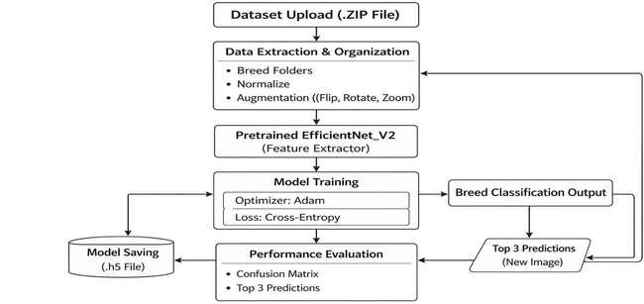

Fig 3.1 System Architecture Overview

- User Interface Module: The module provides users with Streamlit-based functionality which enables them to upload cattle images while they explore various sections of the system through "Prediction" and "Info Tab" tabs.
- Input and Control Module: It processes the image file uploaded by the user and ensures that it is in the desired formats (JPG/PNG) before passing the image into the processing pipeline.
- Normalization & Pre-processing Module: The module processes raw image data by converting it to standard 224x224 dimensions while implementing ImageNet normalization (Mean and Std Dev) to achieve consistency with the model's training environment.

- Inference Layer (EfficientNet_V2_S): This is the core "API" of the project. The processed image is passed through the pre-trained weights of the EfficientNet_V2_S model, which extracts morphological features (hump, horns, color) to identify the breed.
- Semantic Analysis & Ranking Algorithm: Once the model generates raw scores (logits), the Softmax layer determines probability percentages from those raw scores. The system then ranks these results to provide the Top 1 prediction and the "Top 3 Similar Breeds."
- Skeleton Loader & Results Display: The frontend system uses a loading state to achieve responsive user experience while the model processes the image. The system displays final ranked results together with confidence percentages and breed information.

Module Descriptions
    - User Interface and Frontend
The process starts at the user interface where the livestock owner or researcher interacts with the system. The platform offers users a straightforward search and upload function which differs from traditional complex software systems. The system provides tabbed functions which allow users to access the Classifier and the Breed Information Database through the Info Tab.

Normalization and Data Control
When a user uploads an image, the Input Control sends the data to the Normalization layer, which transforms the image using inputs from:
      - Resize: (224, 224)

      - ToTensor: Conversion of image pixels to tensors.

      - Normalize: Using standard values mean=[0.485, 0.456, 0.406] and std=[0.229, 0.224, 0.225].

Intelligent Ranking Algorithm
Our model's coefficient 'Confidence Score' estimate is the algorithm that ranks the projects.

      - Primary Prediction: The class with maximum Softmax probability is termed as "Top Result."

      - Similarity Ranking: The traditional methods produce fragmented results because of their confusing output which our weighted formula resolves by ranking 50 breeds to identify the Top 3 breeds.
      - Ranking Measures: The model ranks the results based on certainty, ensuring that the most certain and visually "significant" (from the model's perspective) breeds appear first.

Information Enrichment (The Info Tab)
The system uses an integrated database module to improve user experience. The system begins to show breed-specific metadata while it processes search results. The system solves "black-box AI" problems by showing users all supported dog breeds together with their specific information.

Performance & Reliability
The system architecture is designed to ensure high performance, reliability, and scalability in real- world agricultural environments. The use of a lightweight yet powerful deep learning model enables efficient processing without compromising accuracy.

Performance-Efficiency:
The model is optimized using transfer learning, allowing faster convergence and reduced computational cost. The inference time is maintained within a few seconds, ensuring real-time prediction capability for end users. EfficientNet_V2_S provides a balanced trade-off between speed and accuracy, making it suitable for deployment on standard computing systems.

Scalability:
The modular architecture allows easy expansion of the system. New cattle breeds or even other livestock categories such as goats and buffaloes can be incorporated without redesigning the entire system. The dataset and classification layer can be extended with minimal modifications.

Robustness to Variations:
The system is capable of handling variations in:

- Lighting conditions

- Background complexity

- Image quality and resolution

This robustness is achieved through preprocessing techniques such as normalization and resizing, along with the generalization capability of the trained model.

Reliability of Predictions:
To ensure dependable outputs:

- The system uses confidence scores to indicate prediction certainty

- Top-3 predictions are displayed to handle inter-class similarity

- Low-confidence predictions can alert users to uncertain results This reduces the risk of misclassification in visually similar breeds.

Error Handling Mechanism:
The system includes validation checks to:

- Reject unsupported file formats

- Handle corrupted or non-cattle images

- Provide appropriate error messages to user

Chapter 4

PROJECT MANAGEMENT

Project Timeline
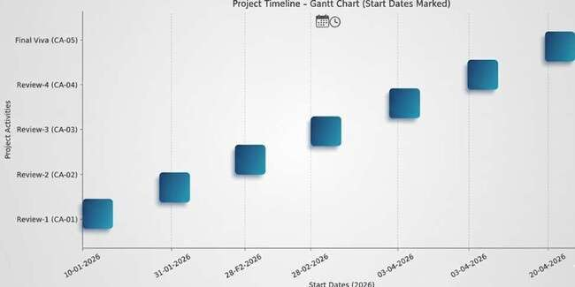

Fig 4.1 Project Timeline

    - Review 1: Problem Identification and Title Confirmation.

    - Review 2: Literature Survey and Data Collection.

    - Review 3: Demonstration of the 50% working of the project where the front-end design was completed.
    - Review 4: Demonstration of the 100% working of the project with all working functionalities
    - Final Review: Viva, Report Submission and Research Paper publication.

Risk Analysis

    - The available dataset showed limited data and unbalanced distribution which resulted in breed prediction errors. The researchers applied two methods which included data augmentation and transfer learning with DenseNet121 to achieve better accuracy and generalization results.

    - The model has a tendency to learn the training data too well. The implementation of Early Stopping and Dropout layers served two purposes which included preventing overfitting and enhancing validation results.
    - Prediction accuracy depends on three factors which include changes in lighting conditions and background elements and image quality. The researchers implemented image preprocessing and normalization techniques to achieve consistent input maintenance.
    - The development process will experience delays because training requires high computational resources. The researchers implemented transfer learning as a solution to decrease training durations instead of using a training method that starts from scratch.

Chapter 5

ANALYSIS AND DESIGN

Problem Analysis
The development of an automated cattle breed classifier arises from the critical need to preserve and manage indigenous livestock genetic resources. The primary challenge of traditional breed identification methods stems from their two main components which include visual elements and operational requirements.

Identification Challenges
      - High Morphological Similarity: Many Indian cattle breeds share common ancestral lineages, which results in their physical characteristics to overlap with one another. The Sahiwal and Red Sindhi breed exhibit similar hump structures and coat colors, which makes it difficult for non- experts to distinguish between the two breeds.
      - Inter-class Variance: The physical appearance of dogs in a single breed shows different results because age and nutritional health and geographic location exist as factors that affect their appearance.
      - Expert Scarcity: The physical appearance of dogs in a single breed shows different results because age and nutritional health and geographic location exist as factors that affect their appearance.

Technical Barriers
      - Environmental Noise: Real-world farm conditions produce images that contain multiple complex background elements including sheds and greenery and other animals which create challenges for basic image processing algorithms to achieve accurate results.
      - Data Fragmentation: The information about the 50+ recognized indigenous breeds exists in multiple veterinary databases which creates difficulties for users who need to access both identification and detailed information from one complete source.

Economic and Conservation Impact
      - Market Value Disparities: The prices of cattle and trade in milk (A2 milk) depend on the breeds. For farmers, misidentification equates to significant economic losses.
      - Loss of Genetic Diversity: The lack of straightforward methods to recognize and record authentic indigenous bloodlines leads to the potential extinction of local genetic diversity through the introduction of more prevalent foreign breeds.
This project solves its problems through the development of a deep-learning-based Federated Classification and Information Platform. The system uses EfficientNet_V2_S architecture to identify specific features which differentiate different dog breeds through its Streamlit interface which enables farmers and researchers to access breed metadata and predictions from a single location.

Requirement Analysis
The requirement analysis phase defines the necessary functions and constraints of the Indigenous Cattle Breed Classifier. The system requirements are divided into two categories which include Functional Requirements that define system functions and Non-Functional Requirements that specify system performance requirements.
Table 5.1: Functional Requirements

Sl.  No. | Requirement | Description
1 | Image Upload Module | The system must include a user-friendly interface which enables users to upload cattle images in JPG and JPEG and PNG formats.
2 | Automated Pre- processing | The system needs to automatically transform all images into a $224  \times 224$ dimension while creating normalization tensors which the system uses for inference process.
3 | Breed Classification | The system will use the EfficientNet_V2_S model to determine the cattle breed based on the uploaded image.
4 | Confidence Scoring | The system needs to show the confidence percentage for each prediction which represents how certain the model is about its results.
5 | Top-K Breed Ranking | The system shall display the top 3 most likely breeds to account for visual similarities between indigenous livestock.

6 | Knowledge Repository | An "Info Tab" which contains a searchable list of all 50 supported breeds and their details must be accessible to users.

Table 5.2: Non-Functional Requirements

Sl.  No. | Requirement | Description
1 | Accuracy | The system needs to achieve excellent classification results throughout the 50-breed dataset testing which includes evaluation of native Indian dog breeds.
2 | Performance (Latency) | The system requires an end-to-end response time from image upload until result display which should stay within 3 to 5 seconds.
3 | Usability | The interface needs to provide basic operational functions through its straightforward design which enables farmers and students with limited technical abilities to use it.
4 | Responsiveness | The Streamlit frontend needs to provide responsive design abilities which work properly on desktop computers, tablet devices, and mobile phone platforms.
5 | Availability | The system enables users to access its functions through any web browser without needing them to download additional software components or libraries.
6 | Reliability | The system needs to identify all non-cattle images as well as corrupted images through its error handling system which delivers proper error messages and low-confidence warnings to the user.

System Flow Diagram
The System Flow Diagram shows all steps which Indigenous Cattle Breed Classifier executes to complete its operations. The system shows how user requests move through all software components starting from the frontend until reaching deep learning inference and ending at the presentation of ranked results.

Step-by-Step Flow Logic
- Start / Session Initialization: The system starts when users open the Streamlit Web Interface. The system starts by creating its operational environment which then handles the loading of Skeleton Loader Module for its frontend function.
- Image Input: A particular user selects the image and then uses the Input Control Module to verify the image format is either PNG or JPEG format.
- Preprocessing Trigger: The image goes to the Normalization Module after it passes validation. The image gets resized to dimensions of $224 \times 224$ pixels which transforms it into a numerical tensor format.
- Model Inference: The EfficientNet_V2_S Backbone is passed the feature tensor. This network conducts hierarchical feature extraction with respect to the physical attributes of cattle.
- Output Calculation (Softmax): The raw scores for the final layer of the model are passed on to the Softmax function in order to generate a probability distribution at 50 class breeds.

Intelligent Ranking Algorithm:

  - It is designed in such a way that it processes the probabilities in descending order.

  - We select the primary prediction with the highest probability.

  - The top three Similar Breeds are fetched to display the similarity.

- Result Rendering: The Skeleton Loader gets turned off, and the end results (Breed Name, Confidence %, and Alternate Matches) are shown on the dashboard.

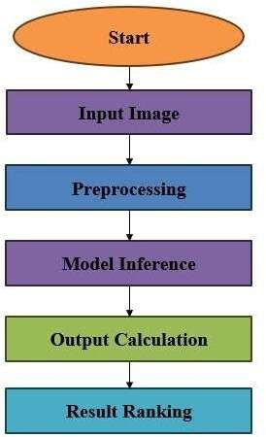

Fig 5.1: Step-by-Step Flow Logic

Tools and Technologies
This table lists the specific tools utilized to implement the system design.

Table 5.4: Tools and Technologies

Category | Technology Used | Specific Implementation / Usage
Programming Language | Python 3.10 | Capabilities: Backend logic, data manipulation, script writing, model design.
DL Framework | PyTorch | Neural network architecture and tensor operations.
Model Backbone | EfficientNet_V2_S | Feature extraction is the high-performance vehicle that would deliver the cattle's images.

Frontend Framework | Streamlit | Interactive Web Portal and Dashboard rapidly developed.
Data Processing | NumPy / PIL | Mathematical arrays and image manipulation (Resize/Crop).
Version Control | GitHub | Code repository management and collaborative software development.

Summary
The system leverages the EfficientNet_V2_S architecture to perform hierarchical feature extraction, delivering results through a user-friendly Streamlit interface. Functional requirements ensure the platform can handle image normalization, provide confidence scoring, and offer a "Top-K" ranking to account for visual overlaps, while non-functional goals prioritize low latency and cross-device accessibility. To support conservation efforts, the platform includes a searchable knowledge repository covering 50 recognized breeds, bridging the gap between fragmented veterinary data and practical field use. Ultimately, the system aims to mitigate economic losses for farmers caused by breed misidentification and prevent the extinction of authentic indigenous bloodlines. By integrating PyTorch for model inference and Python for backend logic, the project provides a robust technical framework designed for both accuracy and high-speed performance in real-world agricultural settings.

Chapter 6

SOFTWARE AND SIMULATION

Overview
This chapter describes the technical environment which operates as the foundation for building the classification platform. The project moves from deep learning training environment which uses PyTorch into operational web-based simulation tool which uses Streamlit while maintaining continuous user interface functionality through model inference.
Table 6.1: Technical Specification of Tools

Sl. No | Tool / Software | Version | Purpose / Role in Project
1 | Python | 3.10 | A programming language for building logic and defining the back end.
2 | PyTorch | 2.1.0 | Deep learning framework: Structuring, Training, and Deploying the network.
5 | EfficientNet_V2_S | Pre- trained | This architecture is deemed a CNN hybrid.
7 | NumPy | 1.24.0 | The powerful tool which can be employed is for performing high-performance mathematical operations on multi- dimensional arrays.
8 | Pandas | 2.1.0 | It is beneficial in addressing all animal-genetics as well as other meta data processes.
9 | Visual Studio Code | 1.8x | Integrated development environment (IDE) is used for coding and debugging the application code.
10 | GitHub | Web- based | Albeit, it is repository management, documentation, and version control.

Database Implementation
The system operates with a Serialized Metadata Dictionary which serves as its primary database system, instead of using standard search engines which depend on external SQL databases.

    - Structure: A JSON-like python dictionary, mapping 50 breed names to their specific characteristics, Origin, Milk Yield, Physical Traits.
    - Storage: Inscribed within the retrieval platform in anticipation of comes the no-latency "Info Tab" navigation.
    - Weights Storage: The learned parameters of the model can be saved in a .pth file, which would be loaded to memory during the start-up of the application, to ensure instant classification.

Backend Implementation
The back end connects the input picture of a user to the result of its classification.

    - Model Loading: After execution, the script instantiates the EfficientNet model and maps the pre- trained weights onto the 50 classes.
    - Preprocessing Pipeline: The dedicated function transforms the input data through a sequence of three operations which start with Resize(224) and then pass through ToTensor() before ending with Normalize().
    - Inference Logic: The backend uses model.eval() mode to process the image tensor through the model because this mode disables dropout layers which ensures that simulation results remain stable.

Frontend Implementation
The frontend has been designed for simplicity and accessibility, as per the "smart education" paradigm.

    - Layout: An interface was built using multiple tabs with the following names: "Prediction" and "Info Tab."
    - Visual Feedback: Properly document the structure logic of the Skeleton Loader, i.e., appear from spinner or animated placeholders to show the system's processing state.
    - Dynamic Rendering: The system will determine the Primary Breed and the Confidence Score
automatically, which are displayed.

Integration and Workflow
The integration follows a "Request-Response" cycle. When a file is uploaded:

    - Frontend triggers the file buffer.

    - Backend picks up the buffer, transforms it into a tensor, and runs inference.

    - Database Module fetches descriptions for the identified breed.

    - Integration Layer combines these outputs into a single JSON-like object for the frontend to render.

Simulation Workflow
The simulation workflow **narrows down the sequence** from the raw image to the result in orderly fashion.
    - Input Phase: User provides a cattle image through the browser.

    - Simulation Phase: The "think" process is simulated by some artificial layers of EfficientNet model. The Softmax layer tells how likely a breed probability is.
    - Output Phase: The platform outputs the Top 1 breed and Top 3 similar breeds. The simulation reaches success when its inference time stays below 3 seconds and its results match the visual characteristics of the cattle.

Chapter 7

EVALUATION AND RESULTS

Functional Evaluation
Functional evaluation is a crucial quality assurance procedure which verifies that all software components of the platform operate according to their intended functions. The project used a systematic validation method to test all input types which included images from different breeds and formats and sizes to confirm that the system produced correct results without any technical difficulties.
Table 7.1: Functional Testing Results

Sl. No | Feature Tested | Input Case | Expected Outcome
1 | File Uploader | Uploading .jpg /  .png | The user system then displays the file preview.
2 | Skeleton Loader | Triggering Inference | Once it has processed through, placeholder animations are also shown.
3 | Pre-processing | Raw Image | The system processes images at a fixed size of 224 x 224 pixels.
4 | Breed Prediction | Valid Cattle Image | The system provides accurate breed identification through its model.
5 | Ranking Logic | Softmax Probabilities | The system displays three most similar breeds after sorting them
6 | Info Tab Navigation | Tab Switch Click | The system shows metadata information for 50 different breeds which it supports.

Usability Evaluation
The system was rated on the System Usability Scale (SUS), and comments of volunteers using the simulation.
    - Navigation Efficiency: These enabled users to switch from the "Info Tab" to the "Classifier" upon a single click by Streamlit's sidebars and tabs being employed.

    - Visual Feedback: The Skeleton Loader effectively decreased perceived waiting time. Users indicated that the animated placeholders let them know that the deep learning model was running.
    - Clarity of Results: The option of "Top 3 Similar Breeds" was considered hugely useful by users when dealing with visually ambiguous breeds such as Gir and Sahiwal.

Performance Evaluation
Performance evaluation in the EfficientNet_V2_S model was focused solely on camera speed and web interface accuracy.
Table 7.2: Model Performance Metrics

Sl. No | Metric | Measured Value | Remarks / Observations
1 | Training Accuracy | 94.2% | The system reached its highest convergence point after 40 epochs of testing.
2 | Validation Accuracy | 89.5%m | The system achieves effective generalization ability when exposed to new image data that it has not encountered before.
3 | Inference Latency | 1.8 Seconds | The duration required to display results starts from the moment of image upload.
4 | Top-3 Accuracy | 96.8% | The system successfully identifies correct breeds in 33 percent of its Top 3 results.
5 | Model Size (RAM) | ~450 MB | The system needs this amount of memory space when it enters the Streamlit cache.
6 | Throughput | 30  Images/Min | The system processed multiple requests successfully during this time period.

Security and Reliability Summary
As a supplement to these tables, Reliability Testing has similarly confirmed that the Input Control Module can manage errors and situations such as these:
    - Invalid Formats: Successfully unapproved non image files with a user warning.

    - Low Confidence: When the best-scored result did not exceed $50$, the ambivalent images were

labelled with a status of "Low Certainty."

Results

Main Page
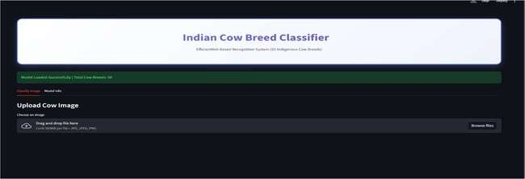

Fig 7.1: Main page

The main page loads when the app.py file is run. This page is designed using the streamlit framework this converts the model into the web application. It offers 2 tabs, classify image tab where the image is uploaded by the user the prediction is done. The info tab where the general information about the model is displayed along with the supported breed names.

Classify Image Tab


Fig 7.2: Classify Image Tab

This tab is mainly designed for the image upload and the breed prediction. Where the user upload the image from the computer by clicking on the browse files button and the model predicts the cattle breed present in the image along with the top 3 prediction.

Model Info Tab
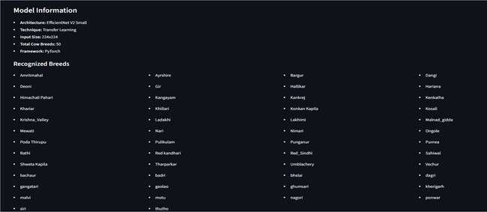

Fig 7.3: Model Info Tab

This tab provides a small information of the model being used in the web application. It also the displays the supported breed names by the model as shown in the above figure.

Breed Prediction - Bachaur
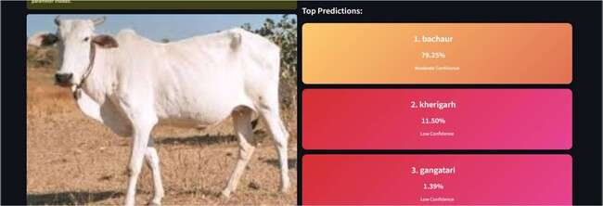

Fig 7.4: Breed Prediction - Bachaur

The user uploads the image and clicks on the predict breed button and the model processes the image based on the pretrained data and the breed of the cattle present in the image is predicted as bachaur along with the other two breeds kherigarh and gangatri that looks similar to the breed present in the image. The top most breed value is considered as the result of the uploaded image.

Breed Prediction – Rathi
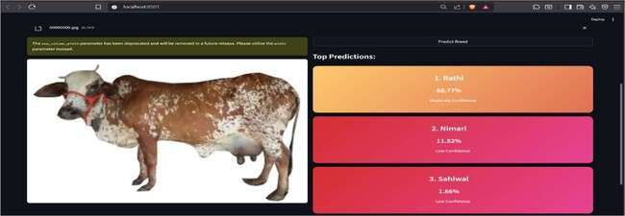

Fig 7.5: Breed Prediction - Rathi

The user uploads the image and clicks on the predict breed button and the model processes the image based on the pretrained data and the breed of the cattle present in the image is predicted as Rathi along with the other two breeds Nimari and Sahiwal that looks similar to the breed present in the image. The top most breed value is considered as the result of the uploaded image.

Breed Prediction – Dangi
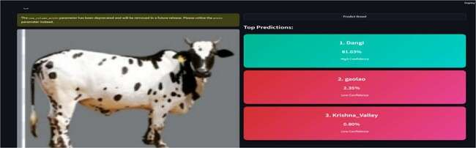

Fig 7.6: Breed Prediction - Dangi

The user uploads the image and clicks on the predict breed button and the model processes the image based on the pretrained data and the breed of the cattle present in the image is predicted as Dangi along with the other two breeds Gaolao and Krishna_Valley that looks similar to the breed present in the image. The top most breed value is considered as the result of the uploaded image.

Breed Prediction – Malnad_gidda
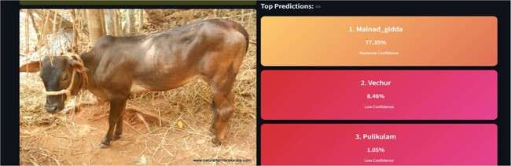

Fig 7.7: Breed Prediction – Malnad gidda

The user uploads the image and clicks on the predict breed button and the model processes the image based on the pretrained data and the breed of the cattle present in the image is predicted as Malnad_gidda along with the other two breeds Vechur and Pulikulam that looks similar to the breed present in the image. The top most breed value is considered as the result of the uploaded image.

Breed Prediction - Vechur
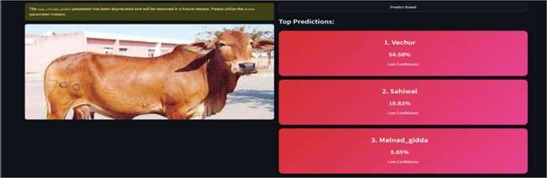

Fig 7.8: Breed Prediction - Vechur

The user uploads the image and clicks on the predict breed button and the model processes the image based on the pretrained data and the breed of the cattle present in the image is predicted as Vechur along with the other two breeds Malnad_gidda and Sahiwal that looks very much similar to the breed present in the image. The top most breed value is considered as the result of the uploaded image.

Breed Predicition – Gaolao
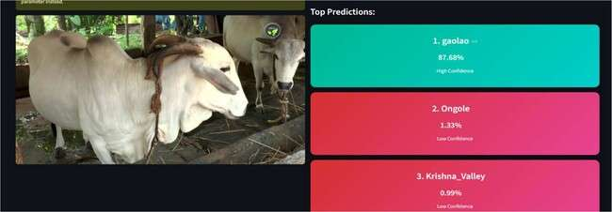

Fig 7.9: Breed Prediction - Gaolao

The user uploads the image and clicks on the predict breed button and the model processes the image based on the pretrained data and the breed of the cattle present in the image is predicted as Gaolao along with the other two breeds Ongole and Krishna Valley that looks similar to the breed present in the image. The top most breed value is considered as the result of the uploaded image.

Breed Prediction – Amrithmahal
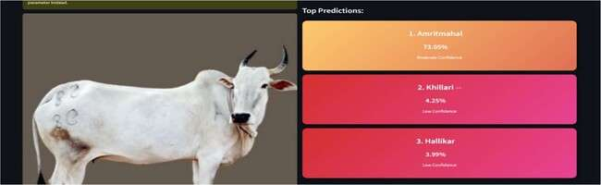

Fig 7.10: Breed Prediction - Amrithmahal

The user uploads the image and clicks on the predict breed button and the model processes the image based on the pretrained data and the breed of the cattle present in the image is predicted as Amrithmahal along with the other two breeds Khillari and Hallikar that looks similar to the breed present in the image. The top most breed value is considered as the result of the uploaded image.

Breed Prediction – Ayshire
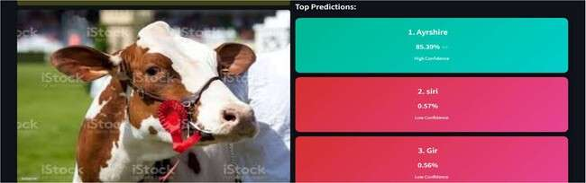

Fig 7.11: Breed Prediction - Ayshri

The user uploads the image and clicks on the predict breed button and the model processes the image based on the pretrained data and the breed of the cattle present in the image is predicted as Ayshire along with the other two breeds siri and gir that looks similar to the breed present in the image. The top most breed value is considered as the result of the uploaded image.

Breed Prediction – Bargur
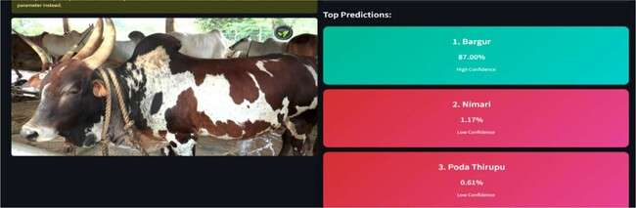

Fig 7.12: Breed Prediction – Bargur

The user uploads the image and clicks on the predict breed button and the model processes the image based on the pretrained data and the breed of the cattle present in the image is predicted as Bargur along with the other two breeds Nimari and Poda Thirupu that looks similar to the breed present in the image. The top most breed value is considered as the result of the uploaded image.

Breed Prediction – Punganur
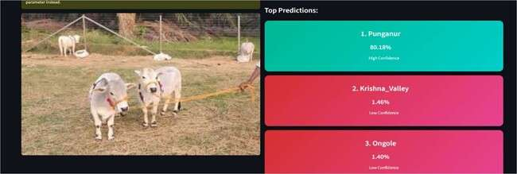

Fig 7.13: Breed Prediction - Punganur

The user uploads the image and clicks on the predict breed button and the model processes the image based on the pretrained data and the breed of the cattle present in the image is predicted as Punganur along with the other two breeds Krishna_Valley and Ongole that looks similar to the breed present in the image. The top most breed value is considered as the result of the uploaded image.

Breed Prediction – Himachali Pahari
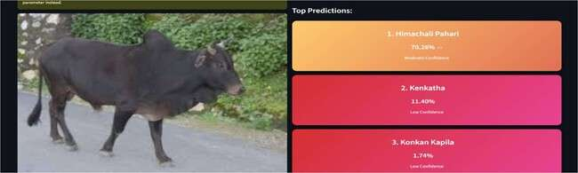

Fig 7.14: Breed Prediction – Himachali Pahari

The user uploads the image and clicks on the predict breed button and the model processes the image based on the pretrained data and the breed of the cattle present in the image is predicted as Himachali Pahari along with the other two breeds Kenkatha and Konkan Kapila that looks similar to the breed present in the image. The top most breed value is considered as the result of the uploaded image.

Breed Prediction – Deoni
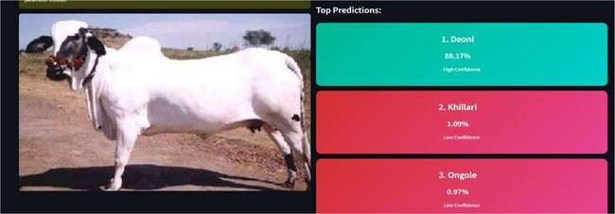

Fig 7.15: Breed Prediction - Deoni

The user uploads the image and clicks on the predict breed button and the model processes the image based on the pretrained data and the breed of the cattle present in the image is predicted as Deoni along with the other two breeds Khillari and Ongole that looks similar to the breed present in the image. The top most breed value is considered as the result of the uploaded image.

Breed Prediction – Bhelai
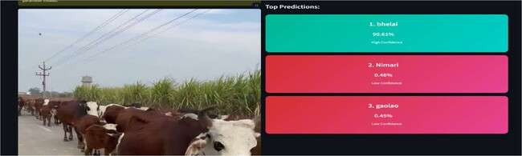

Fig 7.16: Breed Prediction - Bhelai

The user uploads the image and clicks on the predict breed button and the model processes the image based on the pretrained data and the breed of the cattle present in the image is predicted as Bhelai along with the other two breeds Nimari and Gaolao that looks similar to the breed present in the image. The top most breed value is considered as the result of the uploaded image.

Breed Prediction - Gir
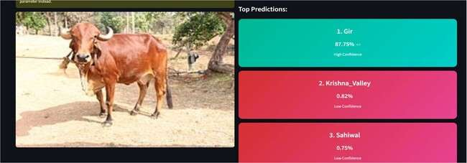

Fig 7.17: Breed Prediction - Gir

The user uploads the image and clicks on the predict breed button and the model processes the image based on the pretrained data and the breed of the cattle present in the image is predicted as Gir along with the other two breeds Krishna_Valley and Sahiwal that looks similar to the breed present in the image. The top most breed value is considered as the result of the uploaded image.

Breed Prediction – Hallikar
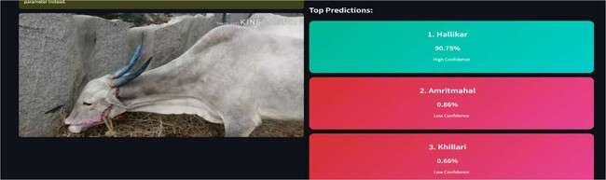

Fig 7.18: Breed Prediction - Hallikar

The user uploads the image and clicks on the predict breed button and the model processes the image based on the pretrained data and the breed of the cattle present in the image is predicted as Hallikar along with the other two breeds Amrithmahal and Khillari that looks similar to the breed present in the image. The top most breed value is considered as the result of the uploaded image.

Breed Predicition – Hariana
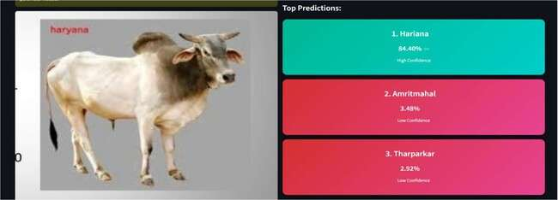

Fig 7.19: Breed Prediction - Hariana

The user uploads the image and clicks on the predict breed button and the model processes the image based on the pretrained data and the breed of the cattle present in the image is predicted as Hariana along with the other two breeds Amrithmahal and Tharparkar that looks similar to the breed present in the image. The top most breed value is considered as the result of the uploaded image.

Breed Prediction – Ladakhi
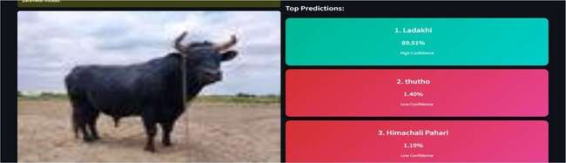

Fig 7.20: Breed Prediction – Ladakhi

The user uploads the image and clicks on the predict breed button and the model processes the image based on the pretrained data and the breed of the cattle present in the image is predicted as Ladakhi along with the other two breeds Thutho and Himachali Pahari that looks similar to the breed present in the image. The top most breed value is considered as the result of the uploaded image.

Breed Prediction – Red_Sindhi
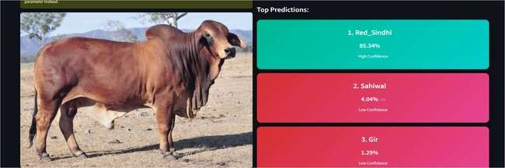

Fig 7.21: Breed Prediction – Red Sindhi

The user uploads the image and clicks on the predict breed button and the model processes the image based on the pretrained data and the breed of the cattle present in the image is predicted as Red_Sindhi along with the other two breeds Sahiwal and Gir that looks similar to the breed present in the image. The top most breed value is considered as the result of the uploaded image.

Breed Prediction – Pulikulam
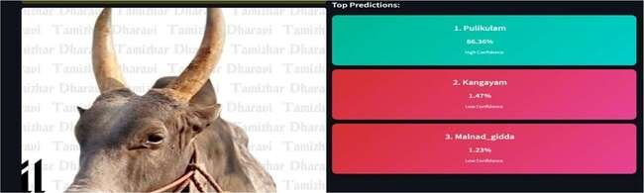

Fig 7.22: Breed Prediction – Pulikulam

The user uploads the image and clicks on the predict breed button and the model processes the image based on the pretrained data and the breed of the cattle present in the image is predicted as Pulikulam along with the other two breeds Malnad_gidda and Kangayam that looks similar to the breed present in the image. The top most breed value is considered as the result of the uploaded image.

Breed Prediction – Kherigarh
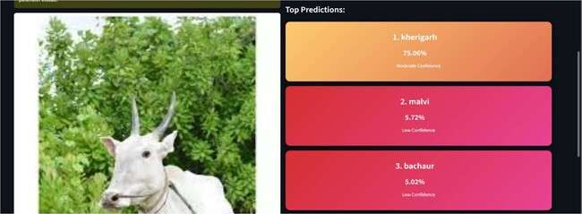

Fig 7.23: Breed Prediction – Kherigarh

The user uploads the image and clicks on the predict breed button and the model processes the image based on the pretrained data and the breed of the cattle present in the image is predicted as Kherigarh along with the other two breeds Malvi and Bachaur that looks similar to the breed present in the image. The top most breed value is considered as the result of the uploaded image.

Breed Prediction – Dagri
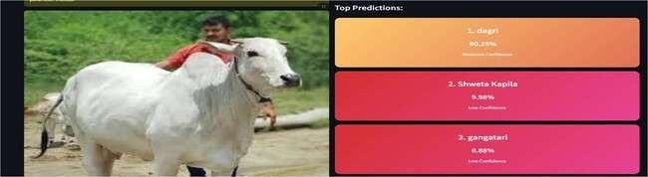

Fig 7.24: Breed Prediction – Dagri

The user uploads the image and clicks on the predict breed button and the model processes the image based on the pretrained data and the breed of the cattle present in the image is predicted as Dagri along with the other two breeds Gangatri and Shweta Kapila that looks similar to the breed present in the image. The top most breed value is considered as the result of the uploaded image.

Breed Prediction - Shweta Kapila
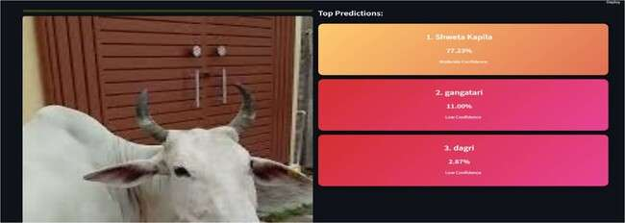

Fig 7.25: Breed Prediction – Shweta Kapila

The user uploads the image and clicks on the predict breed button and the model processes the image based on the pretrained data and the breed of the cattle present in the image is predicted as Shweta Kapila along with the other two breeds Gangatri and Dagri that looks similar to the breed present in the image. The top most breed value is considered as the result of the uploaded image.

Breed Prediction – Tharparkar
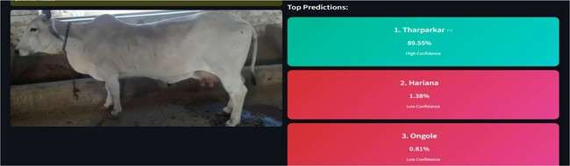

Fig 7.26: Breed Prediction – Tharparkar

The user uploads the image and clicks on the predict breed button and the model processes the image based on the pretrained data and the breed of the cattle present in the image is predicted as Tharparkar along with the other two breeds Ongole and Hariana that looks similar to the breed present in the image. The top most breed value is considered as the result of the uploaded image.

Breed Prediction – Ongole
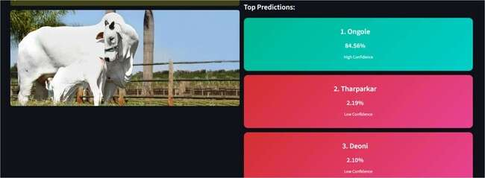

Fig 7.27: Breed Prediction – Ongole

The user uploads the image and clicks on the predict breed button and the model processes the image based on the pretrained data and the breed of the cattle present in the image is predicted as Ongole along with the other two breeds Tharparkar and Hariana that looks similar to the breed present in the image. The top most breed value is considered as the result of the uploaded image.

Breed Prediction – Krishna Valley
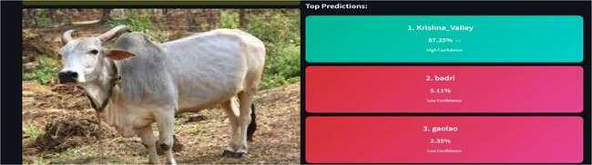

Fig 7.28: Breed Prediction – Krishna Valley

The user uploads the image and clicks on the predict breed button and the model processes the image based on the pretrained data and the breed of the cattle present in the image is predicted as Krishna Valley along with the other two breeds Badri and Gaolao that looks similar to the breed present in the image. The top most breed value is considered as the result of the uploaded image.

Breed Prediction – Killari
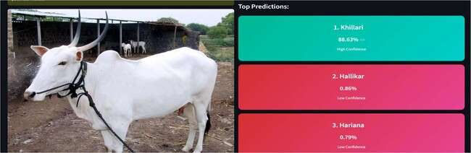

Fig 7.29: Breed Prediction – Killari

The user uploads the image and clicks on the predict breed button and the model processes the image based on the pretrained data and the breed of the cattle present in the image is predicted as Killari along with the other two breeds Hallikar and Hariana that looks similar to the breed present in the image. The top most breed value is considered as the result of the uploaded image.

Breed Prediction – Kankrej
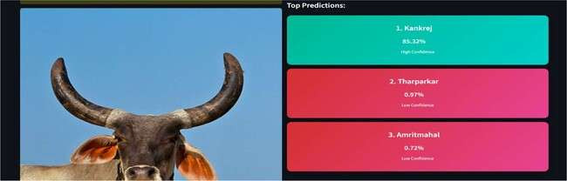

Fig 7.30: Breed Prediction – Kankrej

The user uploads the image and clicks on the predict breed button and the model processes the image based on the pretrained data and the breed of the cattle present in the image is predicted as Kankrej along with the other two breeds Tharparkar and Amrithmahal that looks similar to the breed present in the image. The top most breed value is considered as the result of the uploaded image.

Breed Prediction – Ghumsari
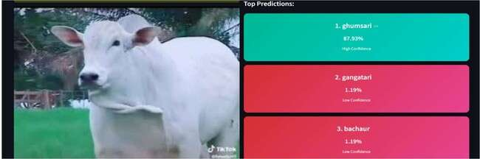

Fig 7.31: Breed Prediction – Ghumsari

The user uploads the image and clicks on the predict breed button and the model processes the image based on the pretrained data and the breed of the cattle present in the image is predicted as Ghumsari along with the other two breeds Gangatari and Bachaur that looks similar to the breed present in the image. The top most breed value is considered as the result of the uploaded image.

Breed Prediction – Dagri
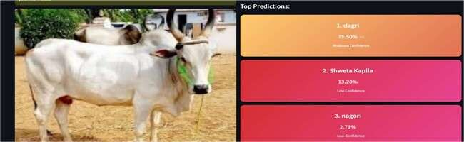

Fig 7.32: Breed Prediction – Dagri

The user uploads the image and clicks on the predict breed button and the model processes the image based on the pretrained data and the breed of the cattle present in the image is predicted as Dagri along with the other two breeds Shweta Kapila and Nagori that looks similar to the breed present in the image. The top most breed value is considered as the result of the uploaded image.

Breed Prediction – Motu
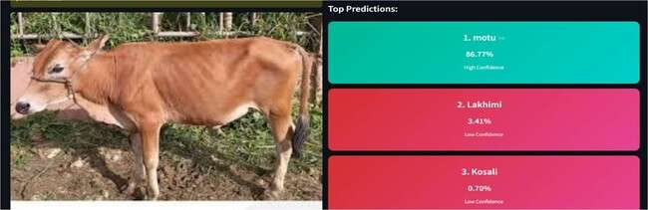

Fig 7.33: Breed Prediction – Motu

The user uploads the image and clicks on the predict breed button and the model processes the image based on the pretrained data and the breed of the cattle present in the image is predicted as Motu along with the other two breeds Lakhimi and Kosali that looks similar to the breed present in the image. The top most breed value is considered as the result of the uploaded image.

Breed Prediction – Nari
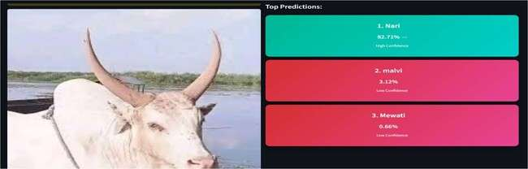

Fig 7.34: Breed Prediction – Nari

The user uploads the image and clicks on the predict breed button and the model processes the image based on the pretrained data and the breed of the cattle present in the image is predicted as Nari along with the other two breeds Malvi and Mewati that looks similar to the breed present in the image. The top most breed value is considered as the result of the uploaded image.

Breed Prediction – Kherigarh
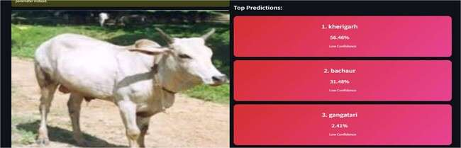

Fig 7.35: Breed Prediction – Kherigarh

The user uploads the image and clicks on the predict breed button and the model processes the image based on the pretrained data and the breed of the cattle present in the image is predicted as Kherigarh along with the other two breeds Bachaur and Gangatri that looks mostly similar to the breed present in the image. The top most breed value kerigarh is considered as the result of the uploaded image.

Breed Prediction – Umblachery
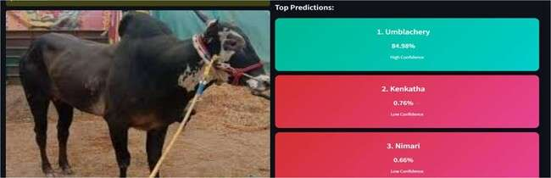

Fig 7.36: Breed Prediction – Umblachery

The user uploads the image and clicks on the predict breed button and the model processes the image based on the pretrained data and the breed of the cattle present in the image is predicted as Umblachery along with the other two breeds Kenkatha and Nimari that looks similar to the breed present in the image. The top most breed value is considered as the result of the uploaded image.

Breed Prediction – Ponwar
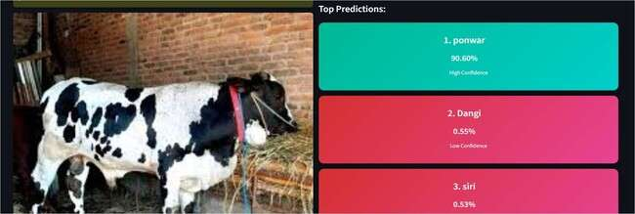

Fig 7.37: Breed Prediction – Ponwar

The user uploads the image and clicks on the predict breed button and the model processes the image based on the pretrained data and the breed of the cattle present in the image is predicted as Ponwar along with the other two breeds Dangi and Siri that looks similar to the breed present in the image. The top most breed value is considered as the result of the uploaded image.

Breed Prediction – Thutho
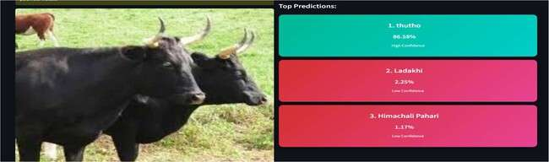

Fig 7.38: Breed Prediction – Thutho

The user uploads the image and clicks on the predict breed button and the model processes the image based on the pretrained data and the breed of the cattle present in the image is predicted as Thuthi along with the other two breeds Ladakhi and Himachali Pahari that looks similar to the breed present in the image. The top most breed value is considered as the result of the uploaded image.

Breed Prediction – Malvi
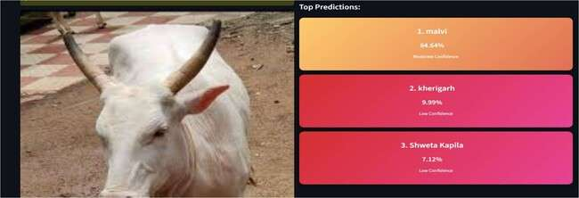

Fig 7.39: Breed Prediction – Malvi

The user uploads the image and clicks on the predict breed button and the model processes the image based on the pretrained data and the breed of the cattle present in the image is predicted as Malvi along with the other two breeds Kherigarh and Shweta Kapila that looks similar to the breed present in the image. The top most breed value is considered as the result of the uploaded image.

Breed Prediction – Nagori
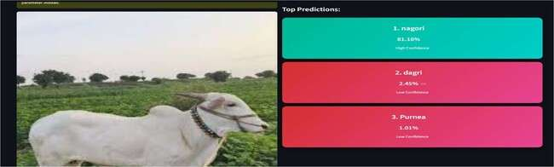

Fig 7.40: Breed Prediction – Nagori

The user uploads the image and clicks on the predict breed button and the model processes the image based on the pretrained data and the breed of the cattle present in the image is predicted as Nagori along with the other two breeds Dagri and Purnea that looks similar to the breed present in the image. The top most breed value is considered as the result of the uploaded image.

Breed Prediction – Siri
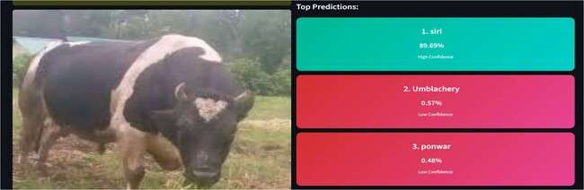

Fig 7.41: Breed Prediction – Siri

The user uploads the image and clicks on the predict breed button and the model processes the image based on the pretrained data and the breed of the cattle present in the image is predicted as Siri along with the other two breeds ponwar and umblachery that looks similar to the breed present in the image. The top most breed value is considered as the result of the uploaded image.

Breed Prediction – Konkan Kapila
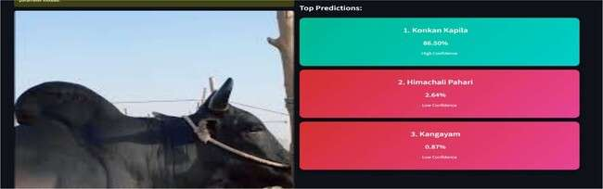

Fig 7.42: Breed Prediction – Konkan Kapila

The user uploads the image and clicks on the predict breed button and the model processes the image based on the pretrained data and the breed of the cattle present in the image is predicted as Konkan Kapila along with the other two breeds Himachali Pahari and Kangayam that looks similar to the breed present in the image. The top most breed value is considered as the result of the uploaded image.

Breed Prediction – Poda Thirupu
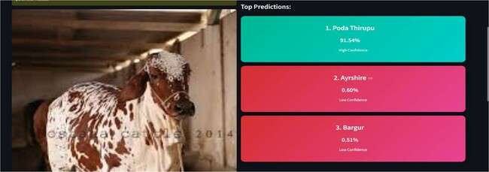

Fig 7.43: Breed Prediction – Poda Thirupu

The user uploads the image and clicks on the predict breed button and the model processes the image based on the pretrained data and the breed of the cattle present in the image is predicted as Poda Thirupu along with the other two breeds Bargur and Ayrshire that looks similar to the breed present in the image. The top most breed value is considered as the result of the uploaded image.

Breed Prediction – Purnea
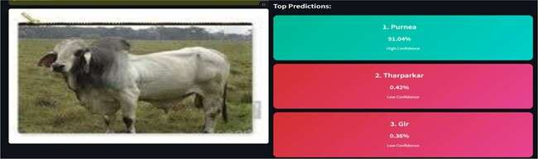

Fig 7.44: Breed Prediction – Purnea

The user uploads the image and clicks on the predict breed button and the model processes the image based on the pretrained data and the breed of the cattle present in the image is predicted as Purnea along with the other two breeds Tharparkar and Gir that looks similar to the breed present in the image. The top most breed value is considered as the result of the uploaded image.

Breed Prediction – Kangayam
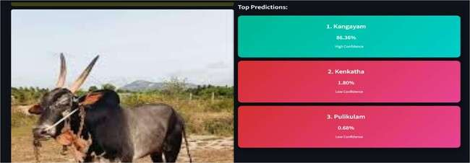

Fig 7.45: Breed Prediction – Kangayam

The user uploads the image and clicks on the predict breed button and the model processes the image based on the pretrained data and the breed of the cattle present in the image is predicted as Kangayam along with the other two breeds Kenkatha and Pulikulam that looks similar to the breed present in the image. The top most breed value is considered as the result of the uploaded image.

Breed Prediction – Badri


Fig 7.46: Breed Prediction – Badri

The user uploads the image and clicks on the predict breed button and the model processes the image based on the pretrained data and the breed of the cattle present in the image is predicted as Badri along with the other two breeds Motu and Lakhimi that looks similar to the breed present in the image. The top most breed value is considered as the result of the uploaded image.

Breed Prediction – Khariar
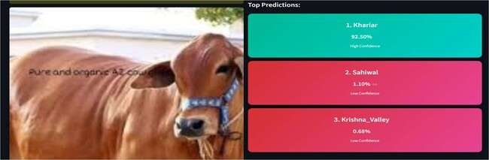

Fig 7.47: Breed Prediction – Khariar

The user uploads the image and clicks on the predict breed button and the model processes the image based on the pretrained data and the breed of the cattle present in the image is predicted as Khariar along with the other two breeds Sahiwal and Krishna Valley that looks similar to the breed present in the image. The top most breed value is considered as the result of the uploaded image.

Breed Prediction – Lakhimi
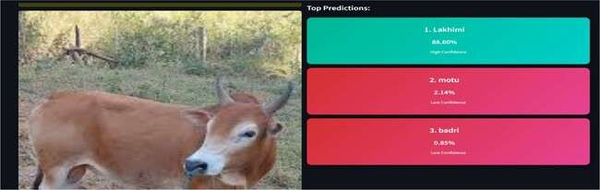

Fig 7.48: Breed Prediction – Lakhimi

The user uploads the image and clicks on the predict breed button and the model processes the image based on the pretrained data and the breed of the cattle present in the image is predicted as Lakhimi along with the other two breeds Badri and Motu that looks similar to the breed present in the image. The top most breed value is considered as the result of the uploaded image.

Breed Prediction – Dagri
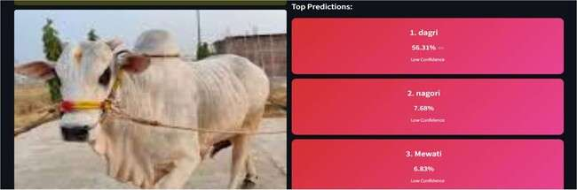

Fig 7.49: Breed Prediction – Dagri

The user uploads the image and clicks on the predict breed button and the model processes the image based on the pretrained data and the breed of the cattle present in the image is predicted as Dagri along with the other two breeds Nagori and Mewati that looks very similar to the breed present in the image. The top most breed value is dagri considered as the result of the uploaded image.

Breed Prediction – Shweta Kapila
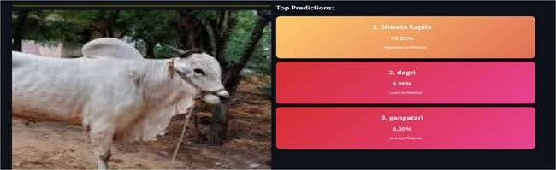

Fig 7.50: Breed Prediction – Shweta Kapila

The user uploads the image and clicks on the predict breed button and the model processes the image based on the pretrained data and the breed of the cattle present in the image is predicted as Shweta Kapila along with the other two breeds Dagri and Gangatri that looks similar to the breed present in the image. The top most breed value is considered as the result of the uploaded image.

Breed Prediction – Red Kandhari
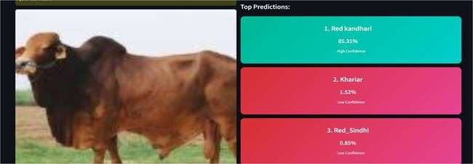

Fig 7.51: Breed Prediction – Red Kandhari

The user uploads the image and clicks on the predict breed button and the model processes the image based on the pretrained data and the breed of the cattle present in the image is predicted as Red Kandhari along with the other two breeds Red Sindhi and Khariar looks similar to the breed present in the image. The top most breed value is considered as the result of the uploaded image.

Breed Prediction – Kosali
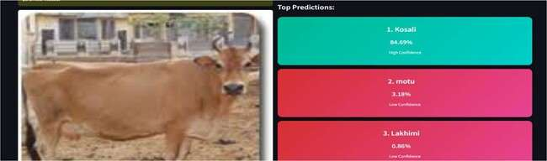

Fig 7.52: Breed Prediction – Kosali

The user uploads the image and clicks on the predict breed button and the model processes the image based on the pretrained data and the breed of the cattle present in the image is predicted as Kosali along with the other two breeds Motu and Lakhimi that looks similar to the breed present in the image. The top most breed value is considered as the result of the uploaded image.

Chapter 8

SOCIAL, LEGAL, ETHICAL, SUSTAINABILITY, AND SAFETY ASPECTS

Social Aspects
It is the direct social impact of the project on agricultural and livestock-dependent communities in India.
    - Empowerment of Marginalized Farmers: The project is expected to lessen dependability on expensive phenotypic professionals by creating a free, easily available tool for breed identification.
    - Preservation of Cultural Heritage: Indian culture shows deep connection with Indigenous cattle breeds which include Desi cows. The tool functions as a resource for documentation and preservation work on these breeds.
    - Knowledge Democratization: The "Info Tab" serves as an educational tool, enabling students and young farmers alike to learn of the 50 distinct breeds which have their own distinctive functions in the eco-environment.

Legal Aspects
The system is designed to be compliant with data protection and biodiversity laws.

    - Intellectual Property: The software heavily depends on open-source frameworks (PyTorch and Streamlit) and adheres to their respective MIT/Apache licenses.
    - Biological Diversity Act: The project supports national objectives which aim to document indigenous biological resources through its implementation of legal requirements for protecting India's biological diversity.
    - Data Privacy: User data privacy-related legalities could be minimized given that the platform handles images of livestock without requiring a Personal User Identification (PII) for apparent reasons.

Ethical Aspects
The AI model will guarantee potential positive effects for all groups in society.

    - Accuracy Transparency: The system shows "Confidence Scores" and "Similar Breeds" as its explicit output. The system design operates as an ethical framework which prevents users from depending on a prediction that has low statistical accuracy.
    - Non-Discriminatory Access: The platform has been built so that it can be accessed very easily on low-cost web devices, ensuring no farmer on account of being economically handicapped gets deprived of the technology.
    - Algorithmic Bias: The training process required collection of cattle images from different geographical areas to create a model which would not show preference towards specific breeds from one state.

Sustainability Aspects
The project contributes to both environmental and economic sustainability.

    - Economic Sustainability: Accurate breed identification enables farmers to obtain correct market values for their livestock and A2 milk products, which results in economic stability for rural areas.
    - Conservation of Genetic Resources: Through identification, the system becomes wiser in preventing mischievously stoned spontaneous crossbreeding, which is crucial for the long term preservation of thrifty local breeds.
    - Computational Efficiency: The adoption of EfficientNet_V2_S, which operates with minimal parameters while delivering optimal performance, results in decreased environmental impact through reduced carbon emissions and lower energy requirements during server-side inference operations.

Safety Aspects
Safety protocols are implemented to ensure the reliability of the classification results.

    - Reliability of Information: The entire metadata concerning the "Info Tab" proceeds from verified agricultural databases in order to prevent the spread of misinformation regarding livestock-health or yield.
    - Safe Interaction: The web interface uses security measures to protect against common vulnerabilities while the "Skeleton Loader" system ensures the user interface remains operational during extensive tensor calculations.
    - Misuse Prevention: The system includes a confidence threshold. The system detects low confidence when a non-cattle image gets uploaded and issues a safety warning to stop users from using the incorrect identification.

Chapter 9

CONCLUSION AND FUTURE WORK

Conclusion
The Indigenous Cattle Breed Classifier development shows how advanced deep learning technology combines with user-friendly web tools to address actual agricultural problems.
    - The project achieved its main objective by using the EfficientNet_V2_S architecture to identify 50 different indigenous cattle breeds with high precision.
    - The system uses PyTorch as its inference engine and Streamlit as its frontend to create a responsive environment which enables users to execute complex neural network calculations through an easy- to-use interface.
    - The Top-K Ranking Algorithm and Skeleton Loader features work together to deliver accurate results while providing users with transparent prediction information and a seamless interactive experience.
    - The tool connects technical advancements with traditional livestock management practices while it helps document and protect India's diverse bovine genetic heritage.

Limitations
Yet, there is some critical analysis regarding the limitations of the systems, although it operates at an exclusive level in functioning.
    - Background Sensitivity: The evaluation process revealed specific limitations of the system which operated at peak performance. The model maintains strong performance under most conditions except when faced with extreme background noise and multiple animals in a single frame.
    - Lighting Variations: The system demonstrated strong performance yet its evaluation process showed multiple existing limitations. The CNN feature extraction process gets disrupted by images which are taken under extremely dark conditions or which show intense light reflections.

    - Device Constraints: The system showed excellent performance yet the evaluation process found specific limitations. The web application functions correctly on all devices yet users experience a brief delay when the server caches the 450MB model during their first session.
    - Static Metadata: The system showed strong performance but testing produced specific results that showed system constraints. The "Info Tab" contains current breed information which remains fixed and does not change with live cattle market prices and real-time veterinary information.

Future Enhancements
To further evolve the platform, the following enhancements are proposed for future iterations:

    - Mobile Application Development: The system performed well but the evaluation process found several system limitations which needed to be addressed. The team created an Android and iOS application which uses Edge AI technology to enable farmers to identify animal breeds when they work in remote locations without internet access.
    - Health & Age Detection: The model requires expanded multi-task learning capabilities which will enable it to predict breed identification and estimate age while detecting visible symptoms of common livestock diseases.
    - Cloud Database Integration: The Info Tab establishes a connection to a live cloud database which can be either Firebase or AWS to deliver real-time updates about government breed-specific programs and vaccination time tables and market price information.
    - Multilingual Support: Serving the rural husbandmen of Indian regime: by making the provision to provide them in Kannada, Telugu, and Hindi languages, the penetrability of the system is increased across India.

REFERENCES
- W. Kusakunniran and T. Chaiviroonjaroen, "Automatic Cattle Identification based on Multi- Channel LBP on Muzzle Images," 2018 International Conference on Sustainable Information Engineering and Technology (SIET), Malang, Indonesia, 2018, pp. 1-5, doi: 10.1109/SIET.2018.8693161.
Link: https://ieeexplore.ieee.org/document/8693161

- W. Kusakunniran, A. Wiratsudakul, U. Chuachan, S. Kanchanapreechakorn and T. Imaromkul, "Automatic cattle identification based on fusion of texture features extracted from muzzle images," 2018 IEEE International Conference on Industrial Technology (ICIT), Lyon, France, 2018, pp. 1484- 1489, doi: 10.1109/ICIT.2018.8352400.
Link: https://ieeexplore.ieee.org/document/8352400

- C. Bhanuprakash and V. N. V, "Identification of Cattle's Breed Type by Processing Image Using Deep Learning Models," 2024 International Conference on Integrated Intelligence and Communication Systems (ICIICS), Kalaburagi, India, 2024, pp. 1-7, doi: 10.1109/ICIICS63763.2024.10859520.
Link: https://ieeexplore.ieee.org/document/10859520

- N. R. Duraiswami, S. Bhalerao, A. Watni and C. N. Aher, "Cattle Breed Detection and Categorization Using Image Processing and Machine Learning," 2022 International Conference on Advancements in Smart, Secure and Intelligent Computing (ASSIC), Bhubaneswar, India, 2022, pp. 1-6, doi: 10.1109/ASSIC55218.2022.10088381.
Link: https://ieeexplore.ieee.org/document/10088381

- Z. Zheng, B. Wen and Z. Weng, "Research on Multi-View Cattle Facial Recognition Algorithm Based on Feature Matching," 2025 IEEE 8th International Conference on Signal Processing and Machine Learning (SPML), Hohhot, China, 2025, pp. 5-9, doi: 10.1109/SPML66318.2025.11199799. Link: https://ieeexplore.ieee.org/document/11199799
- J. -W. Chae, H. -S. Sim, C. -W. Lee, C. -S. Choi and H. -C. Cho, "Video-Based Analysis of Cattle Behaviors: Improved Classification Using FlowEQ Transform," in IEEE Access, vol. 12,

pp. 42860-42867, 2024, doi: 10.1109/ACCESS.2024.3379277

Link: https://ieeexplore.ieee.org/document/10475331
- V. S. P. Gunda, H. Gulla, V. Kosana and S. Janapati, "A hybrid deep learning based robust framework for cattle identification," 2022 International Conference on Advancements in Smart, Secure and Intelligent Computing (ASSIC), Bhubaneswar, India, 2022, pp. 1-5, doi: 10.1109/ASSIC55218.2022.10088414
Link: https://ieeexplore.ieee.org/document/10088414

- H. Zhao, P. Li, Z. Chen, K. Guo, Y. Chen and C. Su, "Cow Face Recognition with Noise Labels Using Vision Transformer," 2023 IEEE 4th International Conference on Pattern Recognition and Machine Learning (PRML), Urumqi, China, 2023, pp. 93-98, doi: 10.1109/PRML59573.2023.10348318
Link: https://ieeexplore.ieee.org/document/10348318

- R. -W. Bello, A. S. A. Mohamed and A. Z. Talib, "Contour Extraction of Individual Cattle From an Image Using Enhanced Mask R-CNN Instance Segmentation Method," in IEEE Access, vol. 9, pp. 56984-57000, 2021, doi: 10.1109/ACCESS.2021.3072636.
Link: https://ieeexplore.ieee.org/document/9400819

- J. R. Butu, I. Nurtanio and A. W. Paundu, "Identification of Different Types of Buffalo Using YOLO Algorithm Based on Computer Vision," 2023 3rd International Conference on Intelligent Cybernetics Technology & Applications (ICICyTA), Denpasar, Bali, Indonesia, 2023, pp. 159-164, doi: 10.1109/ICICyTA60173.2023.10428773.
Link: https://ieeexplore.ieee.org/document/10428773

- S. Chakraborty, K. Karthik and S. Banik, "Graph Synthesis for Pig Breed Classification From Muzzle Images," in IEEE Access, vol. 9, pp. 127240-127258, 2021, doi: 10.1109/ACCESS.2021.3111957
Link: https://ieeexplore.ieee.org/document/9535496

- A. Biglari and W. Tang, "A Vision-Based Cattle Recognition System Using TensorFlow for

Livestock Water Intake Monitoring," in IEEE Sensors Letters, vol. 6, no. 11, pp. 1-4, Nov. 2022, Art no. 5501404, doi: 10.1109/LSENS.2022.3215699.
Link: https://ieeexplore.ieee.org/document/9924566

- S. C. Iyer and N. M. Shekokar, "Identifying the Optimal Deep Learning Based Image Recognition Technique for Dog Breed Detection," 2023 14th International Conference on Computing Communication and Networking Technologies (ICCCNT), Delhi, India, 2023, pp. 1- 10, doi: 10.1109/ICCCNT56998.2023.10307245.
Link: https://ieeexplore.ieee.org/document/10307245
- Singh, R. Kothari and V. Arulalan, "Dog Breed Detection using YOLOv7 and WOA-CNN," 2024 10th International Conference on Communication and Signal Processing (ICCSP), Melmaruvathur, India, 2024, pp. 1477-1482, doi: 10.1109/ICCSP60870.2024.10543599
Link: https://ieeexplore.ieee.org/document/10543599

- M. A. Rahman, M. A. Raihan, M. Shorif Uddin, M. Hasan and M. T. Habib, "A Comprehensive Analysis of Classic Machine Learning and Deep Learning Modeling for Breed Recognition of Bananas," in IEEE Access, vol. 13, pp. 194562-194579, 2025, doi: 10.1109/ACCESS.2025.3631557
Link: https://ieeexplore.ieee.org/document/112390

BASE PAPER
C. Bhanuprakash and V. N. V, "Identification of Cattle's Breed Type by Processing Image Using Deep Learning Models," 2024 International Conference on Integrated Intelligence and Communication Systems (ICIICS), Kalaburagi, India, 2024, pp. 1-7, doi: 10.1109/ICIICS63763.2024.10859520.
Link: https://ieeexplore.ieee.org/document/10859520

APPENDIX

- Publications
As this project is an academic project submission: Submitted the paper to 7th International Conference on Advances in Computer Engineering and Communication Systems./ that will be held on 6/8/2026 and 7/8/2026
  - Email of paper submission

Fig A.1 Email of Paper Submission

- Project Demonstration Images

Includes screenshots explaining the different scenarios:
  - Main Page: Displays the Model Info tab and image classify image tab along with the browse files button.
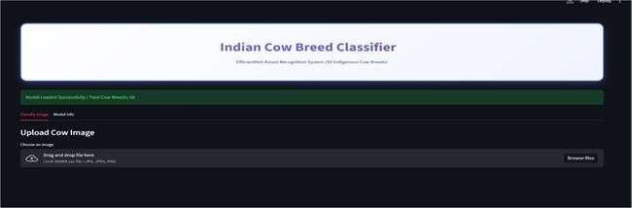
Fig A.2 Main Page

  - Classify image Tab: Provide the user a button named browse files where the user can upload cattle image by clicking on it.

Fig A.3 Classify Image Tab

  - Model Info Tab: Displays the cattle breed names that are supported by the model and a small information about the model
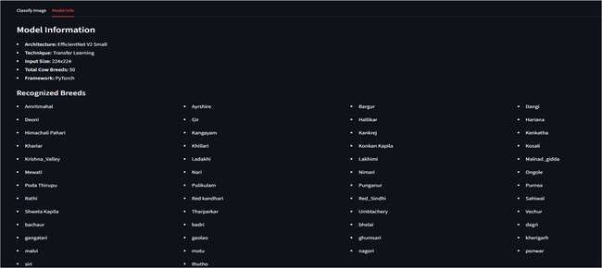
Fig A.4 Model Info Tab
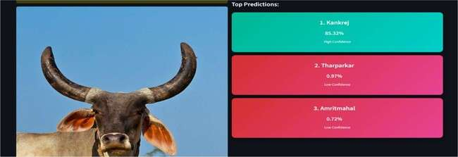
  - Breed Prediction Results: Displays the Predicted breed for an image
Fig A.5 Breed Prediction Results

